Defect id: 02

Description:

* ‘An error occurred’ error message is displayed when trying to view any article

Severity:

* Critical

Priority:

* High

Steps to Reproduce:

1. Navigate to Home page
2. Click on any article

Actual Result:

* ‘An error occurred’ error message is displayed

Expected Result:

* Article should be displayed without any error

Environment:

* Android 10 Virtual device using Android Studio on Windows

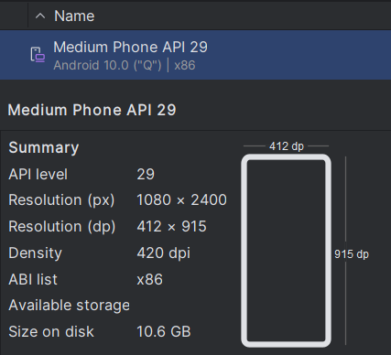

Evidence:

